***Vodka Belvedere 1.75L***

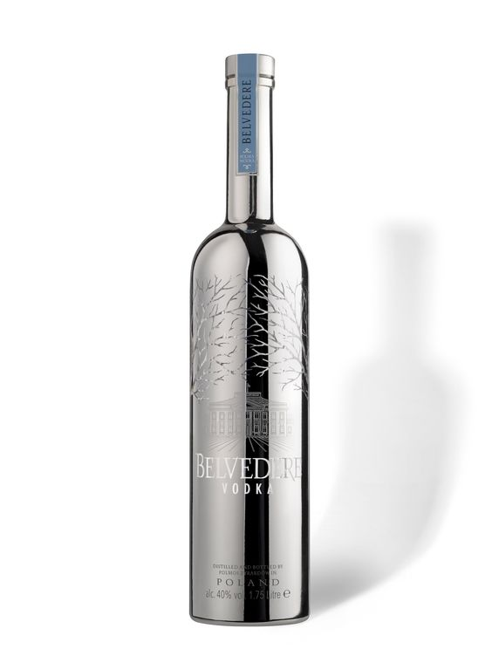

*Belvedere Vodka 1.75L is a vodka originating from Poland. Produced using a unique handcrafted technology from 100% Dankowskie barley and distilled 4 times to ensure outstanding quality, mild flavor and subtle sweetness.  
  
Belvedere vodka was imported to Vietnam by Moet Hennessy, a large reputable corporation, so we are quite confident about the quality of that wine.  
  
Made from clear and pure deep groundwater, Belvedere is made according to the traditional Polish vodka recipe from 600 years ago, so before its modern appearance, Belvedere wine is classic. With a standard strength of 40% according to international standards for vodka, Belvedere can be used in many ways. You can drink Belvedere directly to enjoy the barley taste or you can use Belvedere to make your favorite cocktails."*